John Byrd
CS 465
April 3rd, 2025
Project Draft
Each year, my friends and I participate in a Fantasy Premier League (FPL) competition that spans the entire season. In the 2024-2025 campaign, I built a team that appeared poised to achieve my best finish in six years of competing. Halfway through the season, I was in third place and gaining on the leaders. Then, disaster struck: on December 21st, in the 24th minute of an Arsenal 5-1 thrashing of Crystal Palace, Bukayo Saka, my best performing player and a cornerstone of my strategy, went to ground holding his hamstring. It was later announced that he would need to undergo surgery and consequently be forced to miss an estimated 3 months of the season. I found myself in a precarious situation; I had two options, should I hold Saka throughout the course of his injury, or trade him to one of the other managers for significantly less than what he was worth. After much contemplation, I decided to hold. Unfortunately, in the weeks that followed, my team’s performance plummeted. Thirteen game weeks removed from the injury, with Saka just now returning to the pitch, I find myself in 9th, struggling to avoid the forfeits that await eleventh and twelfth place, rather than racing towards the monetary rewards at the top. This emotional setback illuminated the challenges that fantasy managers face and served as an inspiration for the completion of this project.
In such high-stake leagues, success often demands countless hours of research, trade negotiations, and constant lineup adjustments. Given the time-consuming nature of managing a competitive fantasy team, I set out to develop an intelligent system, capable of assisting in player evaluation and trade decisions by leveraging historical and real time data using machine learning models.
This paper presents a system for evaluating and recommending FPL players based on predicted performance metrics. The approach integrates various machine learning techniques to create a tool that aims to aid users in decision-making, particularly in team selection and trade evaluation. The primary goal of this system is to forecast player performance and assess the potential impact of hypothetical trades, saving fantasy managers time and improving the accuracy of their decisions. Several models are discussed, including regression techniques, decision trees, and ensemble methods, and their effectiveness is compared based on common prediction methods such as Root Mean Squared Error (RMSE) and Mean Absolute Percentage Error (MAPE). Additionally, I explore methods for incorporating contextual data such as opponent difficulty and player form to refine predictions.

I. Project Introduction
Fantasy Premier League (FPL) is a dynamic online game where users draft virtual teams composed of real-life footballers. Virtual teams score points based on the actual performance of their players in English Premier League matches. Given the volume of data and competitive nature of the game, using machine learning to predict future performance has seen much recent interest.
This project focuses mainly on the applications of machine learning in the FPL Draft mode. Draft is a subgenre of Premier League Fantasy in which 8-12 managers compete using unique squads initially formed through a snake draft before the start of the season. Unlike the traditional FPL format, there is no overlap of players across teams, nor do the players have associated monetary values, with a budget constraining player selection. Managers instead modify their teams through trades with one another or using a waiver system to acquire free agents. Waiver order is the inverse of the league table, meaning first priority resides with the worst performing manager. Managers face off head-to-head to see which team has the higher score---based on standard FPL metrics such as goals, assists, clean sheets, minutes played, etc. Wins, draws, and losses are translated into league table points and determine the standings over the 38-gameweek season.
Success is not just found through maximizing raw point totals. Trade negotiation, anticipating rival managers’ strategy, and managing the risk of injury and fixtures adds a layer of strategic complexity that this project aims to address.

II. Related Works
Previous research in this space has tackled similar problems using diverse techniques. Rajesh et al. (2022) developed a player recommendation system using Random Forests and Gradient Boosting Machines, incorporating player statistics, form, and fixture difficulty [1]. They employed Integer Linear Programming to select the best 15-player squad within FPL budget constraints and validated the model using MAE metrics. Their results showed that ensemble models significantly outperformed baseline regressors.
Another paper by Pedii and Jain (2023) focuses on using Random Forests to generate optimal fantasy football lineups [2]. Their model analyzed player form, opposition strength, and tactical elements. Testing across several previous seasons, the model was able to achieve an RMSE of 2.3. The authors concluded that ML-driven lineup selection can often outperform human managers in simulated fantasy leagues, hypothesizing the potential for long term profitability.
Bangdiwala et al. (2022) evaluated three predictive models: Linear Regression, Decision Trees, and Random Forests [3]. Their analysis used features such as player creativity, threat level, and fixture difficulty. They found that while Random Forests performed the best in terms of RMSE and MAE, signs of overfitting were seen, leading them to conclude that the more stable Linear regression model may serve as the best option, highlighting the trade-off between prediction accuracy and generalizability.
III. Approach
Building on the foundation of these previous works, the system will ingest player statistics and team data from the free to use FPL API, as well as other publicly available resources. Feature engineering will involve calculating player form based on recent performance, assessing players’ values, and incorporating fixture difficulty ratings. A key aspect will be designing a framework to evaluate proposed trades by simulating potential outcomes and comparing the projected point gain or loss. This will involve using trained models to predict future performance over multiple game weeks, then assessing whether the trade improves the team’s potential output.
The model will also simulate waiver scenarios, predicting which available players offer the best improvement based on predicted performance and weaknesses in the manager’s current roster. Waiver order will need to be factored in, as players have a likelihood of being taken by managers with higher priority.
A two‑stage modeling pipeline was constructed to capture both short‑term and long‑term performance dynamics in FPL Draft. Raw data were harvested from the official FPL API; including player statistics (goals, assists, minutes), ICT index, and team fixture lists, and enriched with advanced metrics (xG/xGA) from Understat. Data cleaning removed any players with zero minutes, and categorical variables such as team and position were one‑hot encoded. Contextual features were engineered, notably a three‑gameweek rolling average for “recent form” and an opponent‑based “fixture difficulty” score derived from xG rankings. Two separate Random Forest regressors were then trained:
- Short‑Term Model: Tuned via grid search over tree count (100–500) and maximum depth (5–20) to predict the very next gameweek’s points. Hyperparameters were selected using 5‑fold stratified cross‑validation on shuffled gameweeks.
- Long‑Term Model: Designed to forecast cumulative points for the remainder of the season, with hyperparameter tuning on the same grid. Temporal order was preserved by employing time‑series cross‑validation, in which each fold trains on an expanding window of early gameweeks and validates on the next contiguous block. All feature computations were recalculated within each fold to prevent leakage, and final evaluations were performed on a hold‑out set comprising the last 10% of gameweeks.

By combining insights from existing work, with a focus on the unique dynamics of the FPL draft mode, this project seeks to make fantasy sports more accessible, root out any personal bias and enable decision making to be more data driven, and improve the efficiency, both in time and accuracy, of how managers choose their teams.
IV. Experiments and Results
Two complementary experiments were conducted; one evaluating week-to-week accuracy and the other assessing a season-remaining forecast of projected points. The short-term model achieved a cross-validation MAE (Mean Average Error) of 0.95 ± 0.15 and a hold-out MAE of 1.15, with a RSME = 2.40 and R² score of 25%. The long-term model recorded a cross-validation MAE of 2.60 ± 0.42 and a hold-out MAE of 3.05, RMSE and R² of 5.41 and 99% respectively. Both were very much within the boundaries of satisfying a reasonable MAE. Figure 1 summarizes these metrics. Feature importance analyses consistently highlighted recent player-specific form, team form, and fixture difficulty, in the short-term prediction, whereas the long-term prediction highlighted the ICT index; a ‘rating’ given to a player by the game makers of FPL based on Influence, Creativity, and Threat metrics, as the top predictors for each horizon. Learning curves demonstrated MAE stabilization after approximately 60% of the training data for the short-term model, while the long-term model’s curves converge rapidly, reflecting the strong predictive power the model displayed.

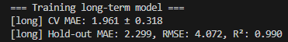
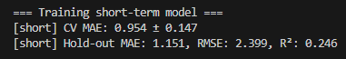
Figure 1.
Shows the calculated metrics used to validate each models’ performance

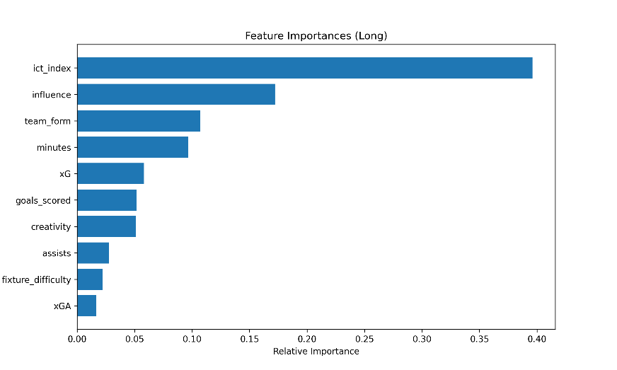
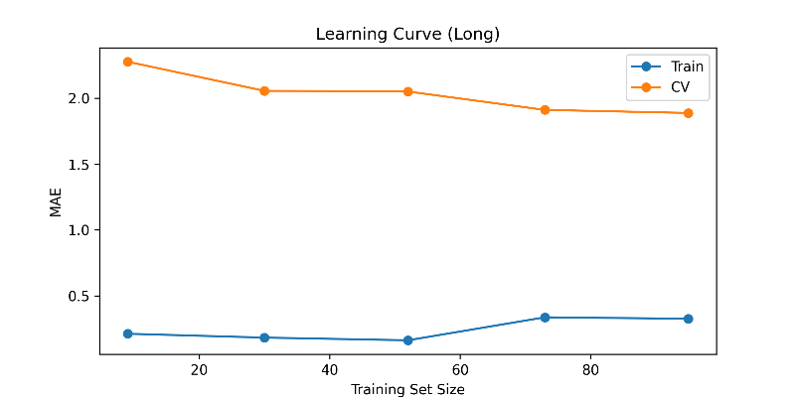

Figures 2 and 3 show feature importance and the learning curve for the long-term model.
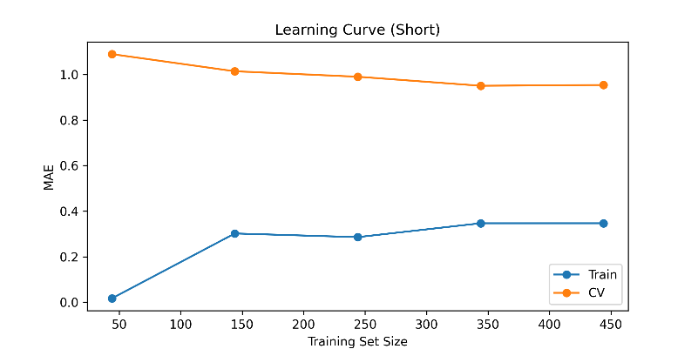
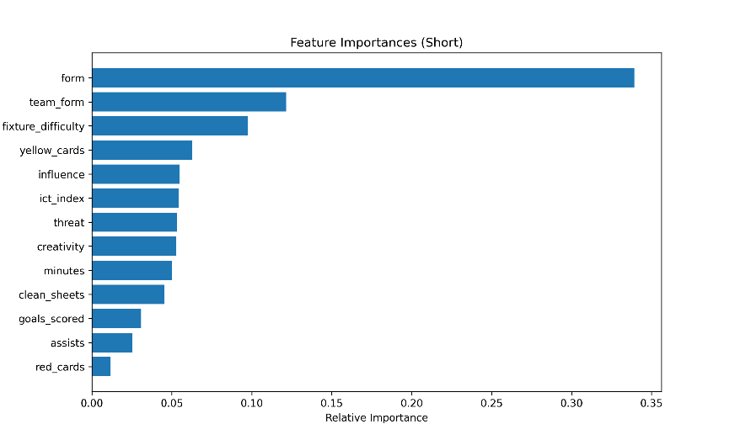

Figures 4 and 5 display feature importance and the learning curve for the short-term model.

V. Analysis
Although both models seemed to meet a reasonable MAE, both RMSE indicate occasional large prediction variance, relating to high volatility events such as unexpected rotation, overperforming a given week, or any of the other dynamic situations that can be unpredictable in sports. These outliers suggest that additional refinement of the feature set could be done in order to improve robustness, by attempting to predict injuries or forecasting manager rotation. The long-term prediction may also be affected by there being very few remaining gameweeks, as a player’s current points are added to what the model projects they will score for the rest of the season. Simulated waiver-pickup and package-trade experiments, validated by inquiring with other managers in the league to deem realism, showed to be quite accurate, with some managers even opting to sign a recommended free agent in the last waiver period.

VI. Conclusion
The dual model Random Forest framework provides accurate, interpretable forecasts for both week-to-week lineup decisions and long-term trade valuations. Transparent feature importances offer trust and an element of improvement when consulting with other managers in the league. Future extensions could include enrichment of contextual features, better integration with the FPL Draft API and an interactive gui, or possibly a better system for recommending trades, such as a DQN network trained on historical data, with rewards and punishments for a positive or negative trade, point value wise. The model can only improve, and as such, it can most definitely provide the assistance to FPL Draft Managers that I entered this project seeking to find.

Works Cited

[1] V. Rajesh, P. Arjun, K. R. Jagtap, S. C. M and J. Prakash, "Player Recommendation System for Fantasy Premier League using Machine Learning," 2022 19th International Joint Conference on Computer Science and Software Engineering (JCSSE), Bangkok, Thailand, 2022, pp. 1-6, doi: 10.1109/JCSSE54890.2022.9836260.
keywords: {Measurement;Industries;TV;Statistical analysis;Fixtures;Machine learning;Media;Recommendation System;Fantasy Sports;Machine Learning;Statistics;Football},
[2] A. Peddii and R. Jain, "Random Forest-Based Fantasy Football Team Selection," 2023 9th International Conference on Advanced Computing and Communication Systems (ICACCS), Coimbatore, India, 2023, pp. 1822-1826, doi: 10.1109/ICACCS57279.2023.10113019.
keywords: {Training;Profitability;Computational modeling;Forestry;Predictive models;Prediction algorithms;Data models;Random Forest;Decision Trees;Performance prediction;Optimal lineup;Data analysis;Back testing;Profitability;Income Generation},
[3] as 2nd Asian Conference on Innovation in Technology (ASIANCON), Ravet, India, 2022, pp. 1-6, doi: 10.1109/ASIANCON55314.2022.9909447.
keywords: {Technological innovation;Machine learning algorithms;Linear regression;Games;Forestry;Predictive models;Prediction algorithms;Linear Regression;Decision Tree;Random Forest;Fantasy Premier League},

